**Build a Workflow from Scratch with SAP Cloud Platform Workflow Management**DEV163

Exercise 2.2 | Integrate Business Rules with Workflow  
Archana Shukla / SAP

Table of ContentS

[OVERVIEW 3](#_Toc53350368)

[integrate BUSINESS RULES with workflow 4](#_Toc53350369)

[execute and Monitor WORKFLOW 9](#_Toc53350370)

[APPendix 11](#_Toc53350371)

[Import Sample Workflow 11](#_Toc53350372)

# OVERVIEW

Estimated time: 30 minutes   
Prerequisite: You have to run Exercise 2.1 before running this exercise.

**Business Rules** in SAP Cloud Platform Workflow Management enables business users & application developers to automate their decisions and enhance their decision-making experience. Integration and consumption are the key. There are 4 **consumption patterns** that you can use to leverage the power of business rules capabilities in your applications/solutions.

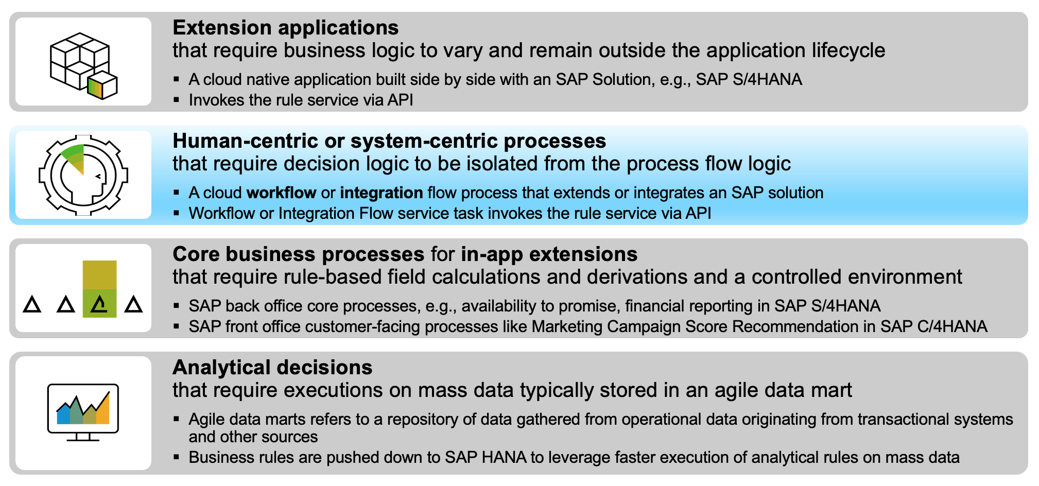

**Pattern 2** talk about how business rules can be used to abstract the decision logic in process orchestration scenarios. **Workflow** and **Business Rules** work harmoniously to provide an unmatched support to automate decisions in workflow such that the business users can easily modify the rules without changing the process flow. **Business rule service can be accessed in Workflow using a Service Task**.

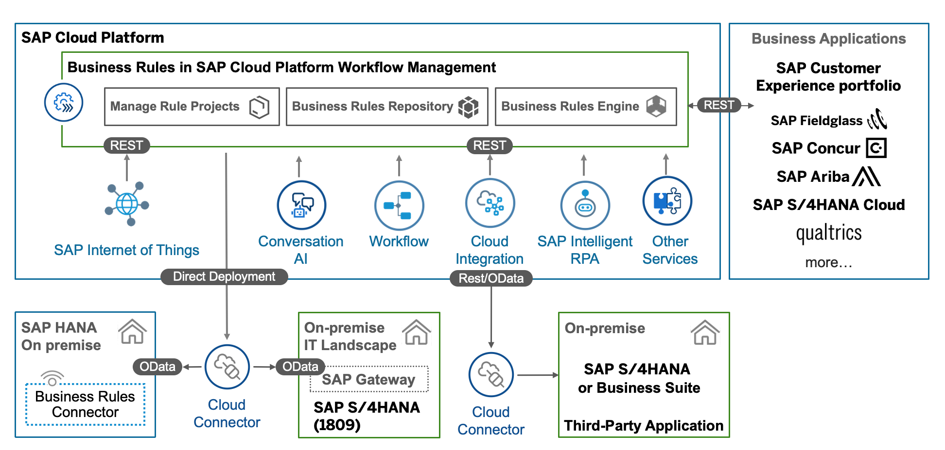

In this exercise, you will integrate the approver determination rules your build in earlier exercise with the capex approval workflow. For that you will configure the Service Task with the details of the Business Rules API.

# integrate BUSINESS RULES with workflow

| Explanation | Screenshot |
| --- | --- |
| There are two kind of rule invocation APIs (a) versioned and (b) working-set. In this exercise, we will integrate business rules with workflow using versioned invocation API. For that, you have to get the rule service ID of the versioned rule service.   1. From **Workflow Management Launchpad Home page**, open Manage Rule Project application |  |
| 1. Select your business rule project and click on **History.** |  |
|
| 1. Click to navigate into the version **1.0.0.** |  |
| 1. Click **Rule Services** tab. 2. Select **Settings**. |  |
| 1. Select the **ID column** which will display the ID of the rule service. 2. Select **OK**. |  |
| 1. Copy the **Rule Service ID** and paste it in a notepad. |  |
| Now we will use the copied rule service information to configure the workflow.  If you have not executed *Exercise 1* *on Workflow* and are coming directly to execute *Exercise 2* then you have to first import the workflow in SAP Business Application Studio.  **To do so, follow the Appendix | Import Sample Workflow.** | |
| 1. Expand the imported workflow project and click to open the workflow and select **Prepare Data** script task**.** 2. From the service task properties, select the script file **PrepareData.js** to open it. |  |
| 1. Paste the **Rule Service ID** into the variable. |  |
| Scroll down in the javascript file, and notice how the input payload is constructed to call the business rules API in the workflow script task.   1. **Save** and close  the file. |  |
| 1. Click to open the workflow again and select **Retrieve Approval Steps** service task.   Notice the service task properties:   * **BUSINESS\_RULES** destination is created when you ran the Booster. This destination contains the credentials to run business rules invocation API. * **Path** is the relative path of the versioned API * **Request variable** is the input payload as constructed in the script task before. * **Response variable** is where the output of the rules will be appended. |  |
| 1. From the workflow model, select **Approval Task (Local Manager)** user task.   In **User Task Properties**, notice the **Users** section. It is directly consuming the output from the business rules execution from the response variable. |  |
| 1. **Save** your changes, build the workflow by right-click on **mta.yaml** to open the context menu and click **Build MTA.** | imb__734 |
| 1. Ensure that the **Build MTA** task exits with code 0, indicating the build is completed. | imb__735 |
| Ensure that a cloud tenant has already been configured. It will be shown in the bottom left corner on a blue bar. If it is not configured yet, then click on the blue bar and click on the blue-bar and follow the wizard to enter the details. | imb__736 |
| 1. You can get the need information about the Login URL, organization name and space name from you trial account.   You have to login with your trial user email and password. |  |
| 1. Select the newly created directory **mta\_archives** to open it. 2. Right-click on the created file **CapexProject-00\_0.0.1.mtar** to open the context menu. 3. Select **Deploy MTA Archive**. | imb__737 |
| 1. Ensure that the **Deploy MTA Archive** task exits with code 0 indicating that the deployment has finished.   Note: You can also click on the 9AA339FC0D8EC0B1 icon in the lower right corner to toggle display of the console panels. | imb__738 |
| Note: Your deployment console should look similar to this with the "**Process finished**" in the second-to-last line, indicating success.  If there are any errors then fix the error, build and deploy the workflow project again. | imb__739 |

# execute and Monitor WORKFLOW

| Explanation | Screenshot |
| --- | --- |
| 1. Open the **Workflow Management Launchpad** Home Page. 2. **Log On** with your trial username and password. 3. Select the tile **Monitor Workflows - Workflow Definitions**. |  |
| Note: **Monitor Workflows** application has Master-Detail layout where you see all the workflows deployed on left. Ensure that the workflow you just deployed - **CAPEX\_00** - is existing.   1. Select the workflow. | imb__742 |
| 1. Select **Start New Instance**. | imb__743 |
| 1. Modify the **RequestId** in the JSON to any string. 2. Adapt the following fields in the JSON element. **Requester**:  * **Name** can be anything * **Email** should be your trial user email ID * **UserId** is your trial user id  1. Select **Start New Instance**. | imb__744 |
| A popup confirms that the workflow instance has been started.   1. Select **Show Instances** to switch to the **Monitor Workflows - Workflow Instances** application where you can view all the running, completed, suspended workflow instances and their details. | imb__745 |
| 1. Select the latest created workflow instance and click on **Refresh** button on top-right corner. 2. From the **EXECUTION LOG**, you will notice that the service task **Retrieve Approval Steps** is completed successfully which executes the business rules service. |  |
| You can also switch to **WORFKLOW CONTEXT** and see the output of the rule execution collected inside **approvalStepResult** element. |  |

# APPendix

## Import Sample Workflow

| Explanation | Screenshot |
| --- | --- |
| 1. Download **CapexProjectSample.zip**  project from [GitHub](https://github.com/SAP-samples/teched2020-DEV163/blob/master/exercises/Exercise3/CapexProjectSample.zip) in your local file system and extract the files. |  |
| 1. Logon to **SAP Cloud Platform Trial Home Page** with your trial username and password. 2. Choose **SAP Business Application Studio**. |  |
| 1. Click on the **Dev Space** to go into the workspace and from **File** menu choose **File |** **Open Workspace.**   Note: If you have no dev space, click the **Create Dev Space** with:   * 1. *Application Type* as SAP Fiori.   2. *Extension* as Workflow Management.   Else select **PLAY** 46F1C2F18C37A68E to start the space if you see the status as **STOPPED**. |  |
|
| 1. Drag and drop the extracted **CapexProjectSample** folder in the *Open Workspace* dialog and click **Open**. |  |
| 1. You will see that the **CapexProjectSample** project is imported into your workspace. |  |